REPUBLIC OF AZERBAIJAN

On the rights of manuscript

ABSTRACT

of the dissertation for the degree of Doctor of Philosophy

PHYSIOLOGICAL AND GENETIC CHARACTERISTICS
OF INCREASING THE YIELD OF WHEAT IN THE
WESTERN REGION OF AZERBAIJAN

Speciality: 2411.02 – Plant physiology
2409.01 – Genetics

Field of science: Biology

Applicant: Elnara Alish Huseynova

Baku – 2022

The dissertation work was performed in the department of biotechnology and Plant physiology of Genetic Resources Institute of Azerbaijan National Academy of Sciences, Laboratory of Grain quality of Research Institute of Crop Husbandry, laboratory of department of biology of Azerbaijan State Agrarian University.

Doctoral supervisor: Doctor of Agrarian Sciences,
Corr.member of ANAS
Zeynal Iba Akparov

Scientific consultant: PhD in biological sciences, associate professor
Arif Tofig Gaziyev
Official opponents: Corr.member of ANAS,
Doctor of biological sciences, professor
İbrahim Vahab Azizov
Doctor of biological sciences, professor
Majnun Shikhbaba Babayev
PhD in biological sciences, associate professor
Gulnara Xankaram Babayeva

One-time Dissertation Counsil BFD 1.26 of the Dissertation council ED 1.26 of Supreme Attestation Commission under the President of the Republic of Azerbaijan operating at the Institute of Botany of The Ministry of Education And Science

Chairman of the Dissertation council
Doctor of biological sciences, professor
Sayyara Jamshid Ibadullayeva
Scientific secretary of the Dissertation council
PhD in biological sciences
Arzu Yusif Huseynova
Chairman of the scientific seminar
Doctor of biological sciences,
associate professor
Afat Dadash-Sharapli Mammadova

GENERAL CHARACTERIZATION
The actuality of the topic. In the conditions of the modern crisis, the world's population is growing rapidly, global climatic and ecological changes occur, so the question of satisfying the demand for food products has arisen. In this regard, ensuring food security has become an overall human problem. An important role in solving this task is played by increasing the yield of wheat (Triticum L.), the main food crop, and the production of high-quality grain products. Cultivated varieties of wheat surpass other grain cultures in terms of nutritional value, providing more than 20% of daily calories and protein in the diet. Now, the state of production of high-quality wheat grain and its position on the world market are decisive in ensuring the food security of countries.
Drought resistant wheat varieties and a number of other factors of the environment have been created in various soil-climatic regions of the republic, and a large research work has been carried out in the direction of increasing grain yield ,.
Until recently, in the western region of the republic, research work was not carried out in the direction of creating high-quality varieties of wheat, resistant to water deficit, drought and other adverse factors in the conditions of a changing climate. Therefore, study the genotypes of wheat of different origins, suitable for the soil and climatic conditions of the western region for the creation of drought-resistant high-yielding, high-quality varieties of bread wheat is important.
It is very important to study the morphophysiological and genetic features of local and introduced genotypes of bread wheat under natural and drought conditions, as well as to use drought resistant varieties adapted to the western region, possessing high photosynthetic activity and have high productivity in breeding. The results will allow the creation of new high-yielding, high quality, resistant varieties for the Western region and will ensure food safety.
The object and subject of the research. Local and introduced bread wheat genotypes belonging to the collection of cereal plants of the National Genbank of Azerbaijan were selected as the object and subject of the research.
Research goals and objectives. The main goal of the research work is the comparative study of the physiological genetic characteristics and yield of local and introduced bread wheat genotypes under normal and drought stress conditions, determining the genetic diversity of their drought resistance with biochemical and molecular markers.
For this, the following tasks are:
- Study the different morpho-physiological characteristics of soft wheat genotypes in the field under normal water and drought stress conditions, finding stable samples;
- Assessment of the content of chlorophyll "a", "b" and carotenoids, identification of drought-resistant samples by changes in the content of chlorophyll;
- Detection of genetic similarity in local and introduced samples of bread wheat by using ISSR, protein markers;
- study of technological quality indicators of grain in bread wheat genotypes.
Research methods. Setting up research experiments, conducting observations, researching morpho-physiological, technological, grain quality, biochemical and genetic characteristics, determination of structural elements of the product and statistical analysis of the results were carried out according to appropriate methods.
Provisions presented to the defense: Comparative study of morpho-physiological signs (amount of chlorophyll in leaves) under normal and drought stress conditions and persistent patterns were determined;
- Correlation relations between productivity elements and quality indicators of different wheat genotypes under normal and drought conditions were investigated;
- Polymorphism between genotypes was studied using biochemical and molecular markers.
Scientific novelty of the research. For the first time in the western region of Azerbaijan, the potential productivity of bread wheat samples of various origins has been determined under normal and drought stress conditions. Because of the effect of drought stress, the area of the assimilation surface of the flag leaf, dry biomass, stomatal conductance and the change in the amount of chlorophyll in the leaves was studied. Based on the studied stress tolerance index, drought-resistant samples were selected, and their quantitative and qualitative indicators were also studied.
Theoretical and practical significance of research. Based on the results of the research, high-quality, resistant and productive Azamatli 95, Azeri, Taraqi, Shafaq 2, Zirva 85, Saba, Ruzi 84, Murov 2, OK00421, Steklovidnaya 24, Vita genotypes were selected for cultivation in the soil and climate conditions of the Western region of Azerbaijan and their use as parental forms in the development of new varieties with higher performance in future breeding studies is recommended.
Approval and application of the work. The results of the dissertation were presented and discussed at the International Scientific Conference "Innovation Problems of Modern Biology" on 90th anniversary of academician Zarifa Aliyeva (Baku-2013), XVIII Republican Scientific Conference of Doctoral Students and Young Researchers (Baku-2013), Kabardino-Balkarian State Agrarian University named after V.M.Kokova. Institute of Economics. Current Problems of Modern Economics: International Scientific - Practical Conference in Memory of Professor BH Zherukova Agrarian Science and Education at the beginning of the XXI century and the problems of modern agrarian economics (Nalchik-2013) At the International scientific-practical conference on "Actual problems and development prospects of the century in the context of globalization" held at the Azerbaijan State Agrarian University (Ganja-2014), New and Non-Traditional Plants and perspectives for Their use, Materials of the XII International Conference (Yalta-2016), 94th anniversary of national leader Heydar Aliyev, “Actual Problems of Modern Natural Sciences” held at Ganja State University (Ganja-2017), The 3rd International Symposium on Euro Asian Biodiversity (Minsk-2017), “Actual Problems of Modern Natural and Economic Sciences” held at Ganja State University dedicated to the 95th anniversary of national leader Heydar Aliyev (Ganja-2018), New and non-traditional plants and perspectives of their use, Materials of the XIII International Conference (Sochi-2018), "Actual Problems of Modern Natural Sciences" (Ganja-2019), held at Ganja State University, dedicated to the 96th anniversary of national leader Heydar Aliyev, At the International Scientific Conference, as well as at the Scientific-Practical Conference on Actual Problems of Modern Biology Dedicated to the Youth Day of the Institute of Microbiology of the Azerbaijan National Academy of Sciences (Baku-2019), Workshop of Institute of Botany of MSE of RA
The name of the institution where the dissertation work was performed. The dissertation work was performed in the department of biotechnology and Plant physiology of Genetic Resources Institute of Azerbaijan National Academy of Sciences, Laboratory of Grain quality of Research Institute of Crop Husbandry, laboratory of department of biology of Azerbaijan State Agrarian University.
The total volume of the dissertation with a sign indicating the volume of the structural sections of the dissertation separately. The dissertation consists of an introduction, chapters, conclusions, a list of 155literary sources, abbreviations and appendices, 20 tables, and 16 pictures. The title part and table contents are 4 pages of 7353 characters, the introduction is 13 pages of 23190 characters, the first chapter is 32 pages of 60541 characters, the second chapter is 14 pages of 19756 characters, the third chapter is 35 pages of 64704 characters, the fourth chapter is 22 pages of 41871 characters. , the fifth chapter is 11 pages of 19824 characters, results are 2 pages of 2025 characters, recommendations are 1 page of 650 characters, the list of 155 literary sources is 17 pages of 26270 characters, abbreviations are 1 page of 553 characters, and appendices are 37 pages of 21788 characters. The total volume of the dissertation consists of 190 pages of computer writing. The general text part of the dissertation (excluding pictures, tables, graphs and the list of references) is 134 pages of computer text or 239914 characters.

BASIC WORK CONTENT
In the introduction, the relevance, purpose of the work, scientific innovation, and practical significance of the problems facing the issue of increasing the productivity of the wheat plant in solving food security against the background of global climate and ecological changes in modern times are indicated and justified.
In the first chapter, a literature review was given, the biological characteristics of the wheat plant, its importance, its role in food security, its origin, systematics, resistance to stress factors, and at the same time the genetic causes and solutions of the physiological and biochemical changes occurring in the wheat plant due to the effect of drought were analyzed. Detailed information on the use and importance of genetic markers in the study of biodiversity in the wheat plant is provided.

Chapter II. MATERIALS AND METHODS
The second chapter provides information about the soil and climate conditions of the research region, the research object and the methods used.
Gray-brown (chestnut), light gray-brown and dark gray-brown (light and dark chestnut) soils prevail in Ganja-Kazakh region. The high level of soil fertility and favorable climatic conditions create conditions for efficient use of agricultural land in the region. The Ganja-Kazakh region has a continental climate with dry and hot summers and mild-hot winters.
Fifty-seven local and introduced genotypes of bread wheat (Triticum aestivum L.) were used as research objects. They were cultivated under drought and normal irrigation conditions and analyzed according to the main productivity elements.
Technological analysis of grain - 1000 seeds weight (DOST-10840-64), vitreousness (DOST-10842-64), quantity and quality of gluten (DOST-13586.1-68) 3, gluten deformation index (in the device IDK-1) sedimentation index (acetic acid based on the macro method) was determined in accordance with state standards. Total nitrogen content was determined by the Kjeldahl method. Polymorphism of gliadin a storage protein, was determined.
To study genetic diversity in wheat samples at the nuclear genome level using ISSR primers, DNA extractions were performed using the STAB (cetyltrimethylammonium bromide) protocol proposed. PCR was performed using the tested selected primers and the amplified DNA fragments were subjected to electrophoresis on 1.2% agarose gel.
Drought resistance of wheat genotypes under field conditions was studied on the instrument "Turgoromer 1" by the water-holding capacity of leaves, and the amount of chlorophyll in the leaves – on the instrument SPAD 502 Plus (Inada, 1965. Minolta, 1989) device.
"a" and "b" chlorophyll content of in the laboratory condition was determined according to the method proposed by the Vavilov Research Institute of Plant Industry 8. A comparative structural analysis of the elements of productivity of wheat samples was carried out based on the method of F.M. Kuperman (1984).
In the statistical analysis of the survey results, SPSS, PAST, Photo Capt. Software were used.
Chapter III. RESEARCH OF WHEAT GENOTYPES TO DROUGHT STRESS UNDER FIELD CONDITIONS
3.1. Evaluation of genotypes based on SPAD value. In order to determine the resistance of plants to drought, the amount of chlorophyll in the leaves was measured three times every five days, starting from the heading stage, as well as under irrigation conditions using a SPAD meter (Figure 1).
During the first measurement, the highest value of chlorophyll was recorded in Saba (61.4), MV06-02 (61.0) and SG-S1915 (60.0) genotypes. The amount of chlorophyll in 25% varied from 55.0 to 59.1, and in 70% from 42.7 to 54.1.
The decrease in the amount of chlorophyll in the leaves due to drought was observed in the genotypes Grekum 75/50, Azeri, Ruzi 84, Guneshli, Shafag and Steklovidnaya 24. The index of tolerance of changes in the amount of chlorophyll in the leaves under the effect of drought was calculated and a dendrogram was compiled. Genotypes are grouped in 4 main clusters on the dendrogram. 16 local and 5 introduced genotypes, totally 21 genotypes showed resistance to drought, 15 were located in clusters I and II and were evaluated as drought-resistant genotypes.
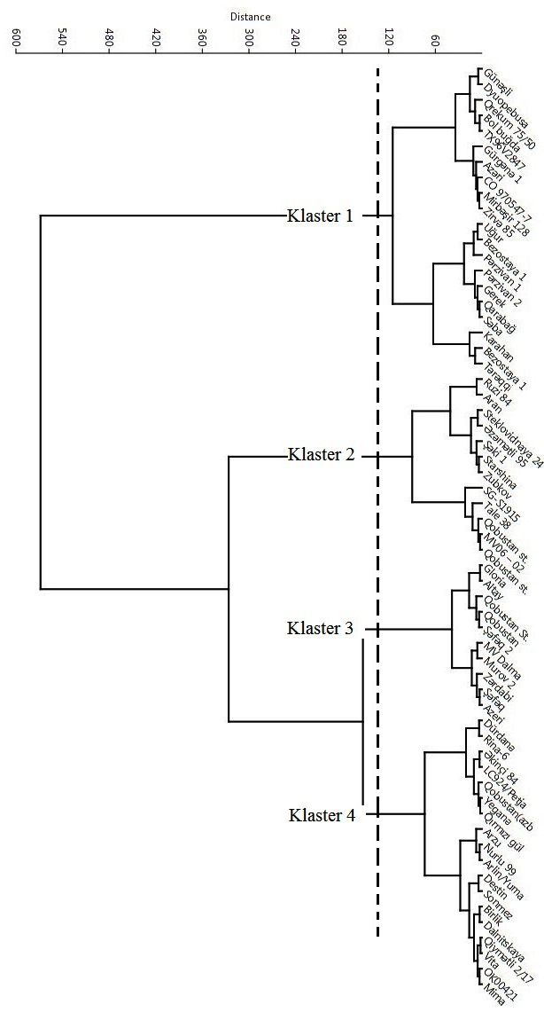
Figure 1. Classification of wheat genotypes according to changes in the amount of chlorophyll as a result of drought impact

3.2. Evaluation of drought resistance in field conditions by Turgorometric method. The drought resistance of wheat genotypes was determined by the leaves of the VIII layer in all varieties and grouped according to the degree of drought resistance I-drought-resistant, II-medium-drought-resistant and III-drought-resistant. It is established that there is a positive relationship between the change in leaf thickness and water loss in the leaves, and the greatest changes in leaf thickness due to drought were observed in the heading, grain formation and milk maturity stages.
The leaf thickness (T2/T1 ratio) of the genotypes included in the first group, changed in the range of 0.82-0.88 mk in the control variant and 0.83-0.89 mk in the drought variant. The genotypes with greater leaf thickness in terms of variants were Tale 38, Arlin/Yuma, MV Dalma and SG-S1915, the difference between leaf thickness (T1-T2) was 11.9-14.1% in the control variant and 11.0-13.1% in the drought variant. A decrease of 1.60-5.30% in the first measurement and 0.62-3.05% in the second measurement was determined among the options due to stress. the genotypes with the largest leaf thickness were Arlin/Yuma, MV Dalma, SG-S1915 and U1254-7-9-2-1/ TX86A5616// Rina-6, each with 0.85 and 0.86 μm in the grain formation stage.
The leaf thickness of the drought- susceptible genotypes included in the third group changed in the range of 0.63-0.74 mk in the control variant and 0.65-0.75 mk in the drought variant. According to variants, the genotypes with lower leaf thickness were Saba, Karabakh 10, Zubkov and Parzivan 1, and the difference between leaf thickness in them was 34.8-37.0% in the control variant and 31.6-34.8% in the drought variant. the above-mentioned genotypes with lower leaf thickness were Saba, Karabakh 10, Parzivan 1 and Zubkov in the grain formation stage. This indicator was in an intermediate position and these genotypes showed moderate resistance to drought in other studied 36 genotypes. This ratio was also reflected in the milk maturity stage in drought-resistant, medium-resistant and sensitive genotypes. The water retention capacity decreased due to the increase in temperature and transport of assimilates to the spike towards the end of the vegetation in all genotypes. In the control version, 2.33-7.00% in the drought-resistant genotypes, 2.32-5.82% in the drought version, and 4.69-9.46% and 3.10-6.64% in the drought-sensitive genotypes, respectively. changed in the interval.
3.3. Calculation of drought tolerance indices of wheat genotypes. The genotypes were studied consecutively for three years in six replicates under irrigation and drought conditions to determine the drought resistance of the investigated local and introduced genotypes of wheat in field conditions. genotypes were sown as usual and phenological observations were made, statistically analyzed for 10 elements of productivity, the stress resistance index was calculated according to Rozile and Gambilin, and at the same time they were grouped according to drought resistance under drought conditions. According to a number of indicators of colossal elements in the main stem, which play an important role in productivity, Bol, Taraki, Akinchi 84, Aran, ТХ96В2847, Arlin/Yuma, Destin, Duopebusa, ОК00421, Mima, Sonmez, Genotypes Steklovidnaya 24 and СГ-С1915 showed resistance to the drought, there was an increase in grain elements. Use these genotypes for selection for drought resistance is recomended.
3.4. Changes in the amount of chlorophyll in leaves under drought stress. Changes in the amount of chlorophyll (a+b) in the leaves of the studied local and introduced genotypes of bread wheat under drought stress were also reflected in the present study. A decrease in the amount of chlorophyll was recorded in 53.0% of genotypes under drought impact. According to the indicators of chlorophyll (a+b), 47.0% of the genotypes showed an increase due to the effect of drought, which allows to obtain a high yield, considering these genotypes to be drought resistant. The results of indicators of chlorophyll (a+b) under the action of drought stress in studied genotypes and compiled a dendogram. As you can see from picture 2, the genotypes are divided into 5 groups on the dendrogram.
25 genotypes that showed resistance to drought (st. Gobustan, Destin, wheat Bol, Durdane, Giymetli 2/17, Sheki 1, Tale 38, MV Dalma, У1254-7-9-2-1/ТХ86А5616//RINA -6, Ekinci 84, Gobustan С, Aran, TX96V2847, Arlin/Yuma, Duopebusa, СГ-С1915, Grekum 75/50, Bezostaya 1, ОК00421, Sonmez, Birlik, Gobustan С2, Mirbashir 128, МВ06-02, Dalnitskaya and Murov 2) They were localized in the 2nd and 2nd clusters and were evaluated as highly drought-resistant genotypes.
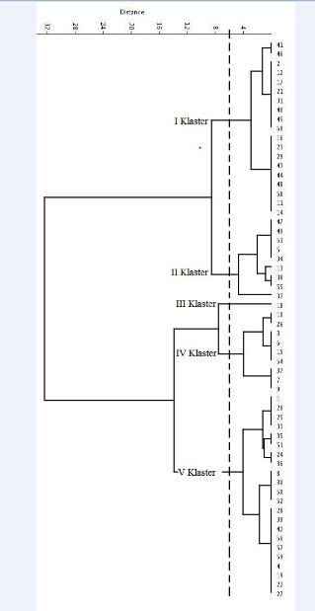
Figure 2. Classification of winter bread wheat genotypes according to the changes in the amount of chlorophyll due to the drought effect

Chapter IV. EVALUATION OF WHEAT GENOTYPES
ACCORDING TO YIELD ELEMENTS AND QUALITY
INDICATORS
4.1. Comparative analysis of yield elements of wheat genotypes under normal and drought stress conditions. In order to evaluate the drought resistance of local and introduced wheat genotypes in field conditions, the genotypes were comparatively studied according to yield and yield elements under irrigation and drought conditions.
The height of the plant genotypes had semi- dwarf and moderate indicators. In 21 out of 57 genotypes, the number of fertile stems varied from 5.2 to 8.9 and showed high results. One of the main signs of increased wheat productivity is the indicator of the elements of the ear (length of the ear, weight of the ear, number of grains per ear, weight of grains per ear and number of ears per ear). Thus, 70.2% of genotypes have long ears, 68.4% - and the amount of grains in the main spike was high under conditions of drought stress. The grain weight in the main spike was average in 29.8% of genotypes and high in 10.5% of both variants, the number of spikes in the main spike was average in 7.01% of genotypes and low in the rest, including standard Gobustan.
In 2013-2016 Statistical analysis of 10 biomorphological-quantitative signs of local and introduced 57 genotypes of winter bread wheat was carried out and linear relationships between elements of yield were established (Table 1).
Table 1
Linear relationship between yield elements of local and
introduced soft wheat genotypes
Traits | CT | PT | PH | LP | LMS | WMS | WGMS | NSMS
PT | 0.734**
PH | 0.018^{n.s} | 0.196^{n.s}
LP | -0.190^{n.s} | 0.083^{n.s} | 0.532**
LMS | 0.048^{n.s} | 0.134^{n.s} | 0.624** | 0.192^{n.s}
WMS | 0.213^{n.s} | 0.219^{n.s} | 0.087^{n.s} | -0.310* | 0.333**
WGMS | 0.397** | 0.205^{n.s} | -0.095^{n.s} | -0.481** | 0.234^{n.s} | 0.703**
WGMS | 0.136^{n.s} | 0.233^{n.s} | 0.104^{n.s} | -0.258* | 0.262* | 0.856** | 0.618**
NSMS | 0.142^{n.s} | 0.038^{n.s} | 0.104^{n.s} | -0.273* | 0.509** | 0.480** | 0.423** | 0.470**

Note: GT-general tillering, PT-productive tillering, PH- plant height, LP- length of peduncle, LM- length of main spike, WMS- weight of main spike, NGMS- number of grains in main spike, WGMS- weight of grains in the main spike, NSMS- number of spikelets in the main spike

According to the results of the research, a positive significant correlation was determined between the productive tillering, the number of grains in the main spike and the total tillering, the length of the spike base and the length of the spike and the height of the plant, the mass of the spike and the length of the spike. At the same time, the number of grains in the main spike and the total tillering and the mass of the spike, a positive correlation was found between the grain weight and the length, weight and number of grains per spike.
A significant positive correlation was determined between the number of spikes in the main spike and the length, weight and number of grains of the spike.
Genotypes selected with high indicators of productivity elements allow to be used as initial material in future breeding.
4.2. Study of wheat genotypes according to the physical and quality indicators of grain. Grain quality indicators are one of the important indicators of productivity. The high value of 1000 grains weight is 47-54 g, and was recorded in the genotypes Bol wheat, Bezostaya 1, Grekum 75/50, Gürgane 1, Ugur, TX96V2847, and Destin. In Arzu, Zardabi, Gerek varieties, 1000 grains weight showed low results, and in others, average results. The a gluten content in 66.7% of the genotypes had an average index, varying between 31.0-38.3%. The gluten content in 26.3% of other studied genotypes, including Standard Gobustan, was low, varying between 23.2-29.5%. Among the investigated genotypes, Parzivan 1 (41.2%), Parzivan 2 (45.3%), Azeri (41.5%) and Saba (44.3%) varieties differed from others due to the high amount of gluten. In general, the amount of gluten in all studied genotypes showed an average result.
The gluten deformation coefficient (GDC) in 14.0% of the studied genotypes (Bol bughda, Bezostaya, Karabakh 10, Zirva 85, CO 970547-7, Arlin/Yuma, Dyuopebusa, Dalnitskaya) was higher than the others, varying between 45.0-77.8. During the study, other genotypes, including the standard Gobustan, had a relatively average index, varying from 80.0 to 104.5. Sedimentation index Bezostaya 1 (32.3 ml), Arzu (33.0 ml), Gurgane 1 (35.0 ml), Parzivan 1 (31.7 ml), Ugur (35.0 ml), Starshina (31.7 ml), CO970547-7 (32.8 ml), Destin (32.4 ml), Bezostaya 1(TR) (34.0 ml), OK00421 (40.0 ml), Dalnitskaya (34.3 ml) genotypes showed moderate results, including standard Gobustan, and poor results in others. It was determined that 10.5% of the grains of local and introduced genotypes are floury, 24.6% are semi-vitreous, and 65.0% are vitreous. Correlation coefficients between grain quality indicators are given in Table 2. It was determined that there is a positive correlation (**P<0.01, r=0.334**) between the amount and quality of gluten and the vitreousness of the grain. Thus, it was found that there is a positive and statistically significant correlation between the sedimentation index and the amount of gluten, and between the sedimentation index and the deformation coefficient of gluten (*P<0.05% positive with probability).
Table 2
Linear relationship between quality parameters of local and
introduced soft wheat genotypes
Traits | 1000 seeds weight, kg | Vitreousness, %- | Gluten content, % | GDI
Şüşəvarilik, %-lə | -0.071^{n.s} | 1 | - | -
Kleykovinanın miqdarı, %-lə | 0.201 ^{n.s} | 0.334** | 1 | -
KDƏ | -0.237 ^{n.s} | -0.032 ^{n.s} | 0.055 ^{n.s} | 1
Sedimentasiya,ml | 0.005 ^{n.s} | 0.183 ^{n.s} | 0.321* | -0.314*
NOTE: GDI- gluten deformation index

Total protein was high only in Parzivan 2, average in 40.4% genotypes, and low in 57.8% in local and introduced wheat genotypes. Comparative analysis of total protein was characterized using SPSS statistical software (Figure 3). The samples were classified into five main clusters in the dendrogram according to the amount of total protein in the genotypes. 20 samples similar to each other in terms of quality indicators were located in the same cluster and constituted 35.0% of the total studied genotypes. However, no significant correlation was observed between 1000 grains weight and vitreousness, between the amount and quality of gluten and 1000 grains weight, between the 1000 grains weight and the sedimentation index, between GDI and the 1000 grains weight, vitreousness of grains and the amount of gluten (n.s = insignificant). . Genotypes with average protein content were collected in the first and second clusters. Evaluation of individual protein fractions in the total protein complex of grain according to amino acid content, selection of new genotypes in the direction of protein fractions richer in non-replaceable amino acids is one of the main directions for improving the quality of wheat grain. Grouping of most of the genotypes in the first cluster in the dendrogram indicates that they are genetically close based on quality indicators.
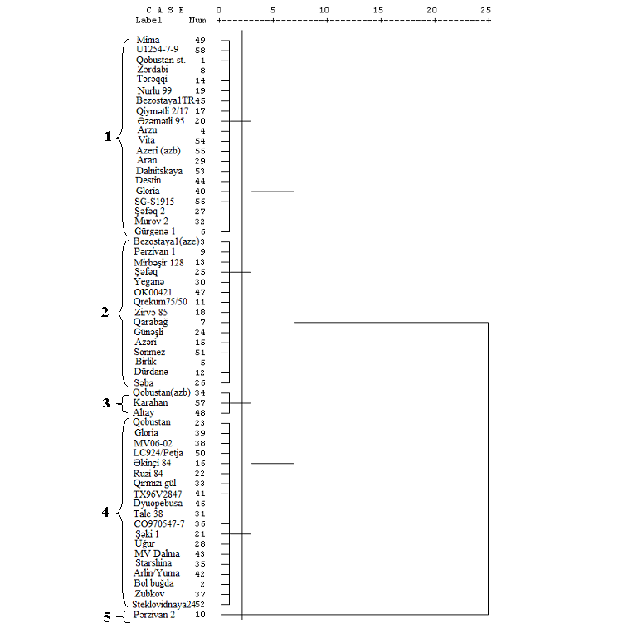
Figure 3. Grouping of domestic and introduced soft wheat genotypes according to total protein

4.3. Selection of initial material for wheat breeding in the western region according to its complex indicators.
Productivity elements, quantitative and qualitative indicators, the amount of chlorophyll pigment, which is the main photosynthetic pigment of chloroplasts in the collection of photosynthetic productivity, were studied in a comparative manner in local and introduced bread wheat genotypes studied under normal and drought conditions. 1, Gurgane 1, Parzivan 2, Grekum 75/50, Durdane, Taraqi, Azeri, Sheki 1, Saba, Shafaq 2 and Murov 2, CO970547-7, Zubkov, Altai, Steklovidnaya 24 having an average value, their role in lodging resistance was determined and convenience of mechanical harvesting is great.
The height, peduncle length indicator, number of productive tillers, spike element indicators of the studied samples under optimal irrigation conditions - Birlik, Bezostaya 1, Gürgane 1, Grekum 75/50, Durdane, Taraqqi, Parzivan 1, Ugur, Azeri, Giymetli 2/17 , Zirva 85, Nurlu 99, Azametli 95, Sheki 1, Ruzi 84, Shafaq 2, Guneshli, Tale 38, Murov 2, SG-S1915, Starshina, CO970547-7, Zubkov, MV06-02, Steklovidnaya 24, Vita and standard Gobustan, and under drought conditions, the genotypes Bol buğda, Taraqqi, Akinchi 84, Aran, TX96V2847, Arlin/Yuma, Destin, Dyuopebusa, OK00421, Mima, Sonmez, Steklovidnaya 24 and SG-S1915 can be used for breeding of drought-resistant genotypes. Mirbaşir 128, Durdane, Akinchi 84, Kızıli 2/17, Saba, Shafaq 2, Yegane, Murov 2, Zubkov, MV06-02, TX96V2847, Mi¬ma, Azeri, SG-S1915 and Karahan showed high result with resistance to drought and increased chlorophyll in the leaf.
During the electrophoretic analysis of the studied genotypes, a sharp polymorphism was revealed among them, which is explained by the wide genetic adaptation of the genotypes in different areas. 5 ISSR primers were used to determine the polymorphism among the 57 studied wheat genotypes, and 11 of the 26 synthesized amplification fragments were found to be polymorphic. During the study, most of the genotypes (67%) that showed closeness from a genetic point of view are local, and seven are introduced genotypes. The information obtained as a result of the application of protein and ISSR markers can be used in the systematization of wheat genotypes and during genetic research conducted on the basis of morphological signs.
Grain quality indicators - gluten content, KDE, sedimentation coefficient, vitreousness, standard Gobustan, Bol wheat, Bezostaya 1, Arzu, Birlik, Parzivan 1, Mirbashir 128, Parzivan 2, Gurgane 1, Shafaq, Ugur, Shafaq during the analysis of the amount of protein. 2, Durdane, Taraqi, Azeri, Zirva 85, Guneshli, Saba, Yegane, Murov 2, Destin, Starshina, CO970547-7, OK00421, Sonmez, Dalnitskaya, Vita and SG-S1915 genotypes differed from others by showing high results.
Based on the obtained results, the above-mentioned wheat genotypes differed from others due to various quantitative and qualitative characteristics, main biomorphological characteristics, high diversity of genetic polymorphism, and their use as initial material for breeding purposes was recommended.

V Fəsil. DETERMINATION OF THE DEGREE OF GENETIC SIMILARITY OF WHEAT SAMPLES BY PROTEIN AND ISSR MARKERS
5.1. Assessment of biodiversity of samples by protein markers. The genetic identification of Gli 1A, Gli 1B, Gli 1D, Gli 6A, Gli 6B and Gli 6D gliadin-encoding locus was performed to assess genetic diversity with biochemical markers in the current study, (Figure 4).

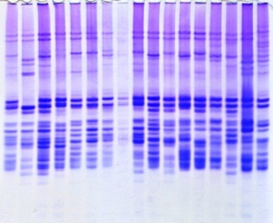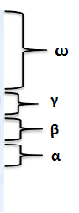
Figure 4. Gliadin electrophorograms of local and introduced bread wheat genotypes.

Electrophorograms showing the results of electrophoresis of gliadin protein of genotypes in polyacrylamide gel are given, where gliadin proteins are conventionally divided into four zones based on molecular mass and speed of movement in polyacrylamide gel: they are called ω-, γ-, β- and α- gliadins. .
It was determined that the electrophoretic patterns of the electrophoretic patterns of gliadin protein are 133, and gliadin spectra are 38. Although the most variety of spectra (18 spectra) occurred in the ω-zone, their pattern by zones (44 patterns) was observed in the α-zone. Polymorphism was high in the ω- and α-zones, and low in the γ- and β-zones (table 3).
However, gliadin reserve proteins with the heaviest molecular mass (99-96 kDa) are formed in the ω-zone, and the lightest ones (15-25 kDa) in the α-zone. The occurrence frequency of patterns and electrophoretic spectra by zones was calculated as a percentage and genetic diversity index. The frequency ω11P was equal to 14.2% (high frequency) the frequency ω28P was equal to 7.1% (average frequency), and the frequency ω2P was equal to 2.4%(low frequency). The index of genetic diversity was calculated as H = 0.963 in the ω-zone. The frequency of β19 P was high (74.1%), the frequency of β2 P was moderate (42.1%), and the frequency of β 4 P was low (5.2%). The genetic diversity index was determined as H = 0.862 in the β-zone. The frequency of α7 P was estimated as high (8.9%), the frequency of α6 P was moderate (4.5%), and the frequency of α26 P was low (2.3%). The genetic diversity index was calculated as H = 0.968 in the α-zone. The frequency of γ-2 S was high (65.0%), the frequency of γ-5 S was moderate (39.0%), and the frequency of γ-1 S was low (16%). The frequency of β-4 S was high (93.0%), the frequency of β-6 S was moderate (47.3%), and the frequency of β-1 S was low (12.2%). Among bread wheat varieties, the frequency of α-2 S was high (88.0%), the frequency α-3 S was moderate (53.0%), and the frequency of α-4 S was determined as low (19.2%).
Table 3
Gliadin patterns identified in local and introduced
bread wheat varieties
№ | Samples | Patterns |  |  |  | № | Samples | Patterns
 |  | α | β | γ | ω |  |  | α | β | γ | ω
1 | 2 | 3 | 4 | 5 | 6 | 7 | 8 | 9 | 10 | 11 | 12
1 | Gobustan | 1 | 1 | 1 | 1 | 30 | Yegana | 25 | 9 | 12 | 24
2 | Bol bughda | 2 | 1 | 2 | 2 | 31 | Tale38 | 26 | 10 | 13 | 25
3 | Arzu | 3 | 2 | 3 | 3 | 32 | Murov 2 | 27 | 11 | 14 | 26
4 | Birlik | 4 | 3 | 4 | 4 | 33 | Qırmızı gül | 28 | 12 | 14 | 27
5 | Gurgana | 5 | 2 | 5 | 5 | 34 | Qobustan (AZB) | 29 | 13 | 15 | 28
6 | Garabagh | 6 | 3 | 4 | 6 | 35 | Starshina | 30 | 14 | 2 | 29
7 | Bezostaya-1 (2015) | 7 | 3 | 4 | 7 | 36 | CO970547-7 | 31 | 14 | 2 | 30
8 | Anza marker | 8 | 4 | 3 | 8 | 37 | Zubkov | 27 | 15 | 16 | 31
9 | Zardabi | 9 | 3 | 5 | 9 | 38 | MV06-02 | 32 | 16 | 17 | 5
10 | Parzivan1 | 10 | 3 | 5 | 10 | 39 | Gerek | 32 | 2 | 4 | 32
11 | Parzivan 2 | 11 | 3 | 4 | 11 | 40 | Gloriya | 33 | 2 | 18 | 33
12 | Grekum75/50 | 12 | 3 | 5 | 11 | 41 | TX96V2847 | 22 | 3 | 19 | 34
13 | Durdana | 13 | 3 | 3 | 5 | 42 | Arlin/Yuma | 34 | 17 | 16 | 35
14 | Mirbashir 128 | 14 | 5 | 6 | 12 | 43 | MV Dalma | 35 | 5 | 20 | 36
15 | Taraggi | 15 | 6 | 6 | 13 | 44 | Destin | 6 | 5 | 21 | 37
16 | Azeri | 16 | 2 | 6 | 11 | 45 | Dyuopebusa | 36 | 18 | 22 | 38
17 | Akinchi-84 | 17 | 7 | 4 | 11 | 46 | OK00421 | 36 | 3 | 23 | 39
Table 3
18 | Giymetli2/17 | 18 | 7 | 6 | 14 | 47 | Altay | 37 | 9 | 22 | 5
19 | Zirve 85 | 19 | 1 | 7 | 15 | 48 | Mima | 38 | 1 | 24 | 11
20 | Nurlu 99 | 1 | 7 | 7 | 16 | 49 | LC927/Petja | 39 | 1 | 7 | 11
21 | Azamatli 95 | 20 | 1 | 7 | 17 | 50 | Sonmez | 40 | 19 | 17 | 1
22 | Shaki 1 | 21 | 2 | 6 | 18 | 51 | Steklovidnaya24 | 7 | 1 | 25 | 1
23 | Ruzi-84 | 22 | 7 | 4 | 19 | 52 | Dalnitskaya | 41 | 5 | 10 | 28
24 | Gunashli | 23 | 1 | 8 | 20 | 53 | Vita | 25 | 3 | 26 | 28
25 | Shafag | 23 | 1 | 9 | 20 | 54 | Azeri (AZB) | 42 | 2 | 25 | 40
26 | Saba | 7 | 8 | 10 | 21 | 55 | SG-S1915 | 43 | 10 | 27 | 41
27 | Shafag 2 | 24 | 1 | 11 | 22 | 56 | Karahan | 20 | 3 | 5 | 3
28 | Ughur | 7 | 2 | 5 | 5 | 57 | U1254-7-9-2-1/ TX86A5616//Rina-6 | 44 | 3 | 28 | 42
29 | Aran | 23 | 3 | 7 | 23 | Total number of patterns |  | 44 | 19 | 28 | 42
 |  |  |  |  |  |  |  | 133

5.2. Grouping of samples based on protein markers. The bands obtained after the extraction and electrophoretic analysis of gliadin from bread wheat grains (electrophoretic spectra) were numbered according to methods "1" and "0" and in order to determine the genetic proximity of the samples cluster analysis based on the UPGMA method was used, and according to the results of the analysis of gliadin a dendrogram was constructed. In the dendrogram, genotypes were located in five clusters (Fig.5.5). The genetic distance index between the studied genotypes ranged from 0.06 to 0.95, and average rate was 0.61 units. Compared to other clusters the first cluster is the largest cluster of genotypes, and implies for 49% of all genotypes. Within the cluster, the genotypes Gunashli və Shafag are located in close proximity to each other, and belong to the graecum species. Only two genotypes-Sheki 1 and Taraggi were located in the fifth cluster. Higher degree of similarity of protein markers was observed in genotypes belonging to the pseudoerythrospermum sp., while genotypes belonging to the lutescens sp. were widespread and found throughout the cluster.

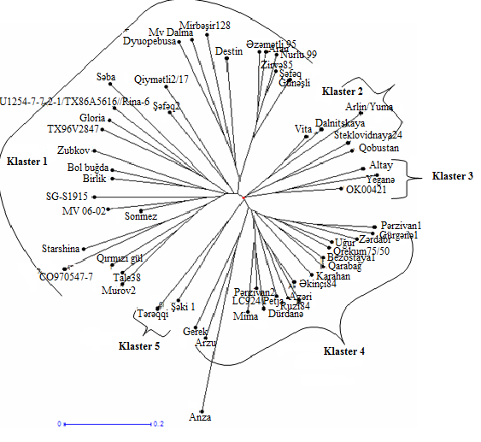
Figure 5.2. Dendrogram reflecting the genetic similarity of bread wheat samples based on the gliadin reserve protein.

5.3. Buğda genotiplərində genetik müxtəlifliyin ISSR markerlərlə qiymətləndirilməsi. The study also used the ISSR (Inter Simple Sequence Repeats) primer for broader study of genetic diversity. As a result of the use of 5 ISSR primers, 26 fragments (elements) of DNA amplification were synthesized, 11 of which are polymorphic (Table 5.1). The amplicon size was within 120-2000 BP. The maximum amount of polymorphs was recorded in primers IS08 and IS11, and the minimum amount was recorded in primer IS18. In the studied samples, DNA polymorphism ranged from 25 to 60% with an average value of 42.2%. During the synthesis of each of these primers, the average values of polymorphs determined as 5.2 and 2.2. The maximum results were obtained by the IS11 primer. Based on the ISSR frequency of occurrence, the genetic diversity index (GMI) of wheat genotypes was calculated, the genetic diversity index in IS18 was low (0.49), and the genetic diversity index in IS08 was high (0.64).
Table 4
Polymorphism and genetic diversity measurements in wheat
genotypes based on ISSR markers
Primer | Number of bands | Number of  polymorphic bands | Polymorphism , % | GDI | PIC | EMR | MRp | Rp | MI
IS08 | 7 | 3 | 43 | 0.64 | 0.40 | 1.29 | 0.42 | 1.28 | 0.52
IS10 | 4 | 2 | 50 | 0.51 | 0.28 | 1.00 | 0.20 | 0.80 | 0.28
IS11 | 5 | 3 | 60 | 0.61 | 0.25 | 1.80 | 0.35 | 1.06 | 0.45
IS15 | 6 | 2 | 33 | 0.62 | 0.37 | 0.66 | 0.55 | 1.10 | 0.24
IS18 | 4 | 1 | 25 | 0.49 | 0.50 | 0.25 | 0.23 | 0.92 | 0.13
Ümumi | 26 | 11 | - | - | - | - | - | - | -
Orta | 5.2 | 2.2 | 42.2 | 0.57 | 0.36 | 1.00 | 0.35 | 1.03 | 0.32

Qeyd: GMƏ-genetik müxtəliflik əmsalı, PIC - polimorf informasiya tutumu, EMR- effektiv multipleks əmsalı, RP-seperasiya (çözüm) gücü, MI- marker indeksi

Ümumiyyətlə, istifadə olunan bütün praymerlər üçün orta GMİ 0.57 təşkil etmişdir. ISSR praymerləri üçün GMƏ orta və yüksək qiymətlər alması, tədqiqatda istifadə olunan buğda genotiplərinin müxtəlifliyinə əsaslanır.
5.4. Grouping of wheat genotypes according to the degree of genetic similarity. In order to determine the genetic distance among the wheat genotypes based on the fragments obtained as a result of applying of ISSR primers, a dendogram was constructed using the UPGMA method based on the Ney's similarity index matrix using the Darwin software (Fig. 5.3). Most of the studied wheat genotypes are localized in the twenty first cluster, most of these genotypes (67%) are local, and seven genotypes are introduced genotypes.

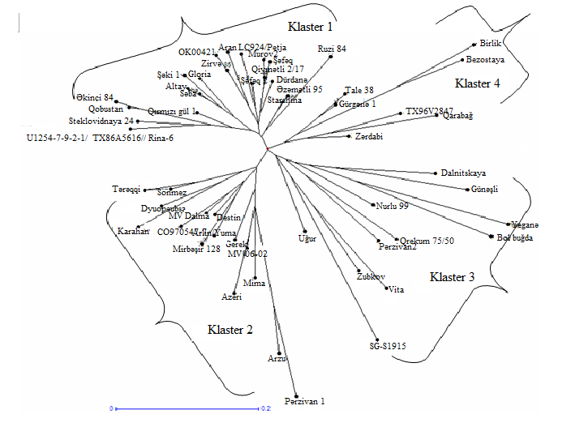
Figure 6. A dendogram reflecting the genetic similarity of wheat
samples based on ISSR markers through cluster analysis

The species included in the cluster were selected for their diversity of origin, since only 5 genotypes from 32 local genotypes of Azerbaijan and genotypes of seven different countries were combined into this cluster. At the same time, four samples introduced from Turkey were located in this cluster. 11 genotypes were located in the third cluster, and five genotypes were introduced, and six genotypes are local genotypes. Tale 38, Gurgana 1, Birlik, Bezostaya 1, TX96V2847, Karabakh and Zardabi genotypes grouped in the fourth cluster are local genotypes and are genetically similar. A number of tendencies have been observed in the grouping of genotypes with botanical diversity. Thus, five of eight pairs were grouped in cluster I by joining in lutescens.
Genotypes included in the graecum species diversity found in all clusters were located as a single group in each cluster. Genotypes included in Pseudoerythrospermum species have different characteristics and are found in separate groups. Thus, the genotypes included in the pseudoerythrospermum species diversity in three variants formed dense groups of local genotypes within the cluster (Akinci 84-Qobustan, Tale 38-Gürgane 1, Karabakh-Zardabi).

RESULTS
- In the Western region, for the first time, according to their productivity and morphophysiological characteristics 32 local and 25 introduced varieties of bread wheat (Triticum aestivum L.) were studied. Bezostaya 1, Durdana, Taraggi, Shafag 2, Tale 38, Zubkov, Birlik, Sheki 1, Ruzi 84, Murov 2, Starshina, Steklovidnaya 24 were distinguished by high results in drought conditions and were evaluated as droughtresistant varieties.
- Genotypes assessed as resistant to drought (standard Gobustan, Arzu, Birlik, Karabakh 10, Zardabi, Durdane, Mirbashir 128, Taraqi, Akinchi 84, Price 2/17, Zirva 85, Azametli 95, Murov 2, MV06-02, TX96V2847, Saba, Fig. 1, Yeganeh, Sonmez, SG-S1915 and Karahan) flag leaves were found to have high chlorophyll content.
- In all genotypes, the water retention capacity decreased due to the increase in temperature and transport of assimilates to the spike towards the end of the vegetation. In the control version, 2.33-7.00% in the drought-resistant genotypes, 2.32-5.82% in the drought version, and 4.69-9.46% and 3.10-6.64% in the drought-sensitive genotypes, respectively. changed in the interval.
- As a result of laboratory studies, among 57 local and introduced bread wheat genotypes, 25 samples with chlorophyll content (a+b) were found to be more productive under drought conditions.
- Based on the linear relationship between physical condition and grain quality, a statistically significant positive correlation (r = 0.334**) was observed between the amount of gluten and the vitreousness of the grain. There was also a positive statistically significant correlation between the sedimentation index and gluten content (r = 0.321*).
- Gliadin electrophoregrams found that the ω-zone was more polymorphic than other zones. Thus, 42 patterns and 18 spectra were found in the ω-zone, 28 patterns and 6 spectra in the γ-zone, 19 patterns and 6 spectra in the β-zone, and 44 patterns and 8 spectra in the α-zone. Based on zonal genetic diversity index it was found that H = 0.963 is in the ω-zone, H = 0.937 in the γ-zone, H = 0.862 in the β-zone, and H = 0.968 in the α-zone.
- As a result of the application of ISSR markers, 26 amplification fragments were synthesized and the average value of polymorphism was 42.2%. The genetic diversity index between genotypes ranged from 0.49 to 0.64, and the average GMA was found to be 0.57 units.

Recommendations
- As a result of the conducted research, the genotypes (Azamatli 95, Azeri, Taraqi, Shafaq 2, Zirva 85, Saba, Ruzi 84, Murov 2, OK0042¬1, Steklovidnaya 24, Vita) showing resistance to drought stress were selected. in the lecture, it is recommended to use it as a parent form in the creation of new high-yielding drought-resistant varieties, as well as in farms.
- It is appropriate to use the data obtained as a result of the application of protein and ISSR markers used for the evaluation of genetic diversity in the studied samples in the systematization of wheat genotypes and during genetic studies carried out on the basis of morphological traits.

List of published scientific works on the topic of the dissertation
1. Гусейнова, Э.А. Действие загрязняющих веществ на биохимические и физиологические особенности кулътур пшеницы (Triticum) и кукурузы (Zea mays) / Э.А.Гусейнова, Л.Н.Велиева, Г.И.Оруджева [и др.] // Azərbaycan Milli Elmlər Akademiyası Mikrobiologiya İnstitutunun Elmi Əsərləri, - Bakı: - 2013. №1, - s.231-235.
2. Гусейнова, Э.А. Влияние органоминеральных удобрений на микрофлору почвы, рост и содержание хлорофилла в проростках пшеницы / Э.А.Гусейнова, А.Т.Газиев, А.М.Гусейнов [и др.] // Azərbaycan Milli Elmlər Akademiyası Mikrobiologiya İnstitutunun Elmi Əsərləri, - Bakı: - 2014. №1, - s. 117-122.
3. Hüseynova, E.Ə. Prolamin zülal markerləri əsasında yerli və introduksiya olunmuş yumşaq buğda (T.aestivum L.) sortlarının genetik yaxınlığının tədqiqi / E.Ə.Hüseynova, Z.İ.Əkbərov, A.T.Qazıyev [və b.] // Əkinçilik Elmi-Tədqiqat İnistitutunun Elmi Əsərləri Məcmuəsi, - Bakı: - 2016. c. XXVII, - s.62- 69.
4. Hüseynova, E.Ə. Tarla şəraitində buğda bitkisinin quraqlıq stresinə davamlılığının öyrənilməsi // - Gəncə: Azərbaycan Dövlət Aqrar Universitetinin Elmi Əsərləri, - 2018. №1, - s. 28-32.
5. Hüseynova, E.Ə. Yumşaq buğda (Triticum aestivum L.) nümunələrinin quraqlığa davamlılıgının laboratoriya şəraitində öyrənilməsi // - Gəncə: Azərbaycan Milli Elmlər Akademiyası Gəncə Bölməsi Xəbərlər Məcmuəsi, - 2018. №1(71), - s.113-120.
6. Huseynova, E. Comparative analysis of genetic diversity of bread wheat genotypes based on protein and DNA markers / E.Huseynova, A.Gaziev, M.Abbasov[et al.] // Bulgarian Journal of Agricultural Science. Sofia, - 2018. v.24 (№ 6), - p. 1034-1041.
7. Huseynova, E.A. Field and laboratory studies of drought resistance of local and introduced common wheat genotype (Triticum Aestivum L). Agrarian Science -2020; 340 (7): 111-114.
8. Hüseynova, E.Ə. Ərzaq təhlükəsizliyinin təmin edilməsində buğda bitkisinin rolu // Görkəmli oftomoloq alim, akademik Zərifə Əliyevanın 90 illik yubileyinə həsr olunmuş Gənc Alimlərin və Tədqiqatçıların III Beynəlxalq Elmi Konfransın materialları, - Bakı: - 2013, - 7-8may, - s.136-138.
9. Hüseynova, E.Ə. Buğda bitkisinin cücərtilərinə stress amillərinin təsirinin öyrənilməsi // Doktorantların və Gənc Tədqiqatçıların XVIII RespublikaElmiKonfransının materialları, - Bakı: - 2013, - 19-20 noyabr, - s.110-112.
10. Hüseynova, E.Ə. Buğda (Triticum L.) bitkisinin məhsuldarlığına rizosferin təsiri // Beynəlxalq Elmi-Praktik Konfrans, - Gəncə: -2014, - 22-24 sentyabr, - s. 98- 100.
11. Гусейнова, Э.А., Газиев А.Т., Велиева Л.Н. Влияние сортовых особенностей культура пщеницы на формирование растителиноризосферного сообщества // Материалы XII международной конференции, - Ялта: -2016, 6-10 июня, - c.187-191.
12. Hüseynova, E.Ə., Əkbərov Z.İ., Qazıyev A.T. Quraqlıq stresinin buğda bitkisinin məhsuldarlıq elementlərinə təsiri // Ümumimilli lider Heydər Əliyevin anadan olmasının 94-cu ildönümünə həsr olunmuş Beynəlxalq Elmi Konfrans, - Gəncə: - 2017, - 4-5 may, - s. 6-8.
13. Hüseynova, E.Ə. Quraqlığın təsirindən yumşaq buğda (Triticum aestivum L.) yarpaqlarında xlorofilin miqdarının dəyişilməsi // Ümumimilli lider Heydər Əliyevin anadan olmasının 95-ci ildönümünə həsr olunmuş Beynəlxalq Elmi Konfransın materialları, - Gəncə: - 2018, - 4-5 may, - s. 75-78.
14. Гусейнова, Э.А., Акперов, З.И., Газиев, А.Т. Влияние засухи на фотосинтетическую деятельность различных сортов пщеницы // Материалы XIII международной конференции, - Сочи: -2018, - 4-8 июня, - c.260-263.
15. Hüseynova, E.Ə. Protein markerləri əsasında müxtəlif yumşaq buğda (T.aestivum L.) sortlarının genetik identifikasiyasının tədqiqi // Ümumimilli lider Heydər Əliyevin anadan olmasının 96-cı ildönümünə həsr olunmuş Beynəlxalq Elmi Konfransın materialları, - Gəncə: -2019, - 4-5 may, - s. 75-78.
16. Гусейнова, Э.А., Мамедова, Е.М., Ахмедова, Б.И., Газиев, А.Т. Экологические стресс факторы и их воздействие на показатели продуктивности растений // Международная Научно – Практическая Конференция Памяти Профессора Б.Х.Жерукова, - Налъчик: - 2013, - c.34-35.
17. Huseynova, E.A.The Determination of Quantity of Chlorophyllin the Wheat Sorts // The 3rd International Symposium on Euro Asian Biodiversity, - Minsk: -2017, - 05-08 July, - p. 362.
18. Hüseynova, E.Ə. Buğda bitkisinin quraqlıq stresinə davamlılığının qiymətləndirilməsi // Azərbaycan Milli Elmlər Akademiyası Mikrobiologiya İnstitutu Gənclər Gününə Həsr olunmuş MÜASİR BİOLOGİYANIN AKTUAL PROBLEMLƏRİ Mövzusunda Elmi-Praktiki Konfransın Materialları, - Bakı: - 2019, - 5 fevral, - s. 40-41.

Defense of dissertation work will be held on ___ November 2022 11:00 at one-time Dissertation council of BFD 1.26/ of Dissertation council of ED 1.26 at the Institute of Botany Ministry of Science and Education Republic of Azerbaijan.

Address: Baku, AZ1004, Badamdar, 40

The dissertation is available at the library of the Institute of Botany of the Ministry of Science and Education Republic of Azerbaijan.

The electronic version of the dissertation and autoabstract is available on the official website of the Institute of Botany of Ministry of Science and Education Republic of Azerbaijan.

The abstract was sent to the necessary addresses on ___ November, 2022.

Signed for print: 14.11.2022
Paper format: 60x84^{1/16}
Volume: 36 253
Print: 20

Əliyev, C.Ə., Əkpərov, Z.İ. Azərbaycanın bitki genetik ehtiyatları // - Bakı: Azərbaycan Milli Elmlər Akademiyasının Xəbərləri, Biologiya elmləri seriyası, - 2002. № 1-6, - s. 57-68.
Джахангиров А.А., Мамедова С.М., Аллахвердиев Т.И., Гусейнова И.М., Гамидов Г.Н. Исследование периода фотосинтетической активности флагового листа мягкой пшеницы в зависимости от водобеспеченности Журнал "Успехи современного естествознания" № 12 (часть 1) 2021, стр. 9-14.
Allahverdiyev T.İ.,.Zamanov A.A., Həsənli L.A.,Novruzov L..E. Quraqlıq stresinin buğda genotiplərinin bəzi fizioloji əlamətlərinə təsiri ƏETİ-nin elmi əsərləri məcmuəsi 1 (30) cild № 1 2019 37-44
Попереля, Ф.А. Полиморфизм глиадина и его связь с качеством зериа, продуктивносью и адаптивными свойствами сортов мягкой озимой пшениц //- М.: Агропромиздат, - 1989. – с. 138-149.
Doyle, J.L. A rapid DNA isolation procedure for small quantities of fresh leaf tissue / J.L Doyle, J.J. Doyle // Phytochem., Bull., - 1987, v. 19, - p. 11–15.
Куперман, Ф.М. Морфофизиология растений. Морфофизиологический анализ этапов органогенезе различных жизненных форм покрытосеменных растений: Учеб. пособие для-студентов >биол. спец. ун-тов / Ф.М. Куперман. М.: Высш. шк., 1984. - 240 с.
Huseynova, E.A. Field and laboratory studies of drought resistance of local and introduced common wheat genotype (Triticum Aestivum L). Agrarian Science -2020; 340 (7): 111-114.
Hüseynova, E.Ə. Prolamin zülal markerləri əsasında yerli və introduksiya olunmuş yumşaq buğda (T.aestivum L.) sortlarının genetik yaxınlığının tədqiqi / E.Ə.Hüseynova, Z.İ.Əkbərov, A.T.Qazıyev [və b.] // Əkinçilik Elmi-Tədqiqat İnistitutunun Elmi Əsərləri Məcmuəsi, - Bakı: - 2016. c. XXVII, - s.62-69.
Huseynova, E. Comparative analysis of genetic diversity of bread wheat genotypes based on protein and DNA markers / E. Huseynova, A.Gaziev, M.Abbasov[et al.] // Bulgarian Journal of Agricultural Science. Sofia, - 2018. v.24 (№ 6), - p. 1034-1041.

